**ЛАБОРАТОРНА РОБОТА № 10**

**Варіант 2**

Використання CSS фреймворка Bootstrap

***Мета*** : Навчитися створювати адаптивні веб-сторінки за допомогою фреймворка Bootstrap.

**Хід роботи:**

**Завдання**:

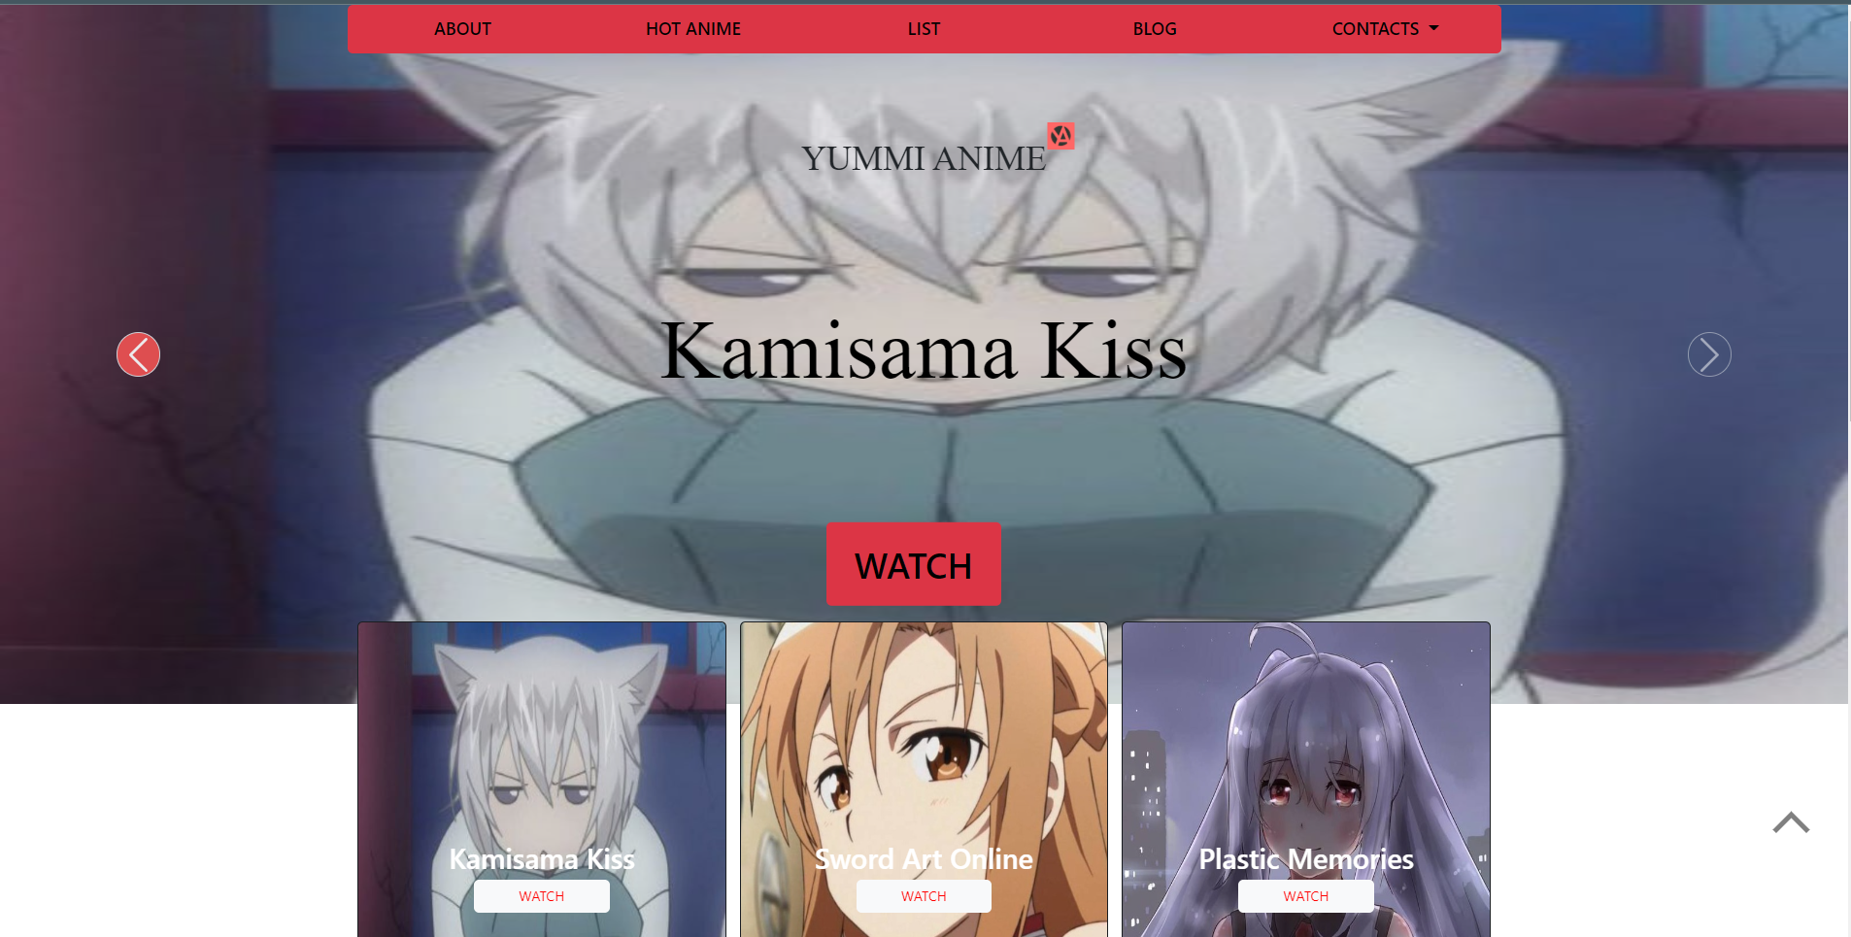

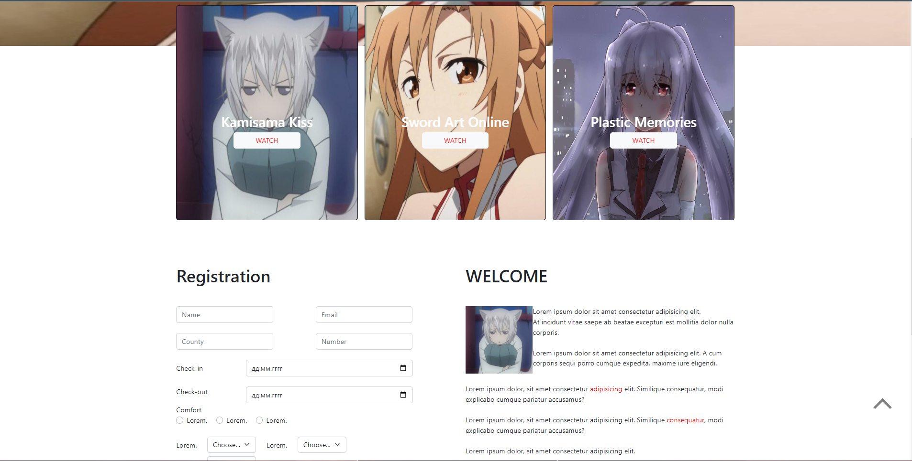

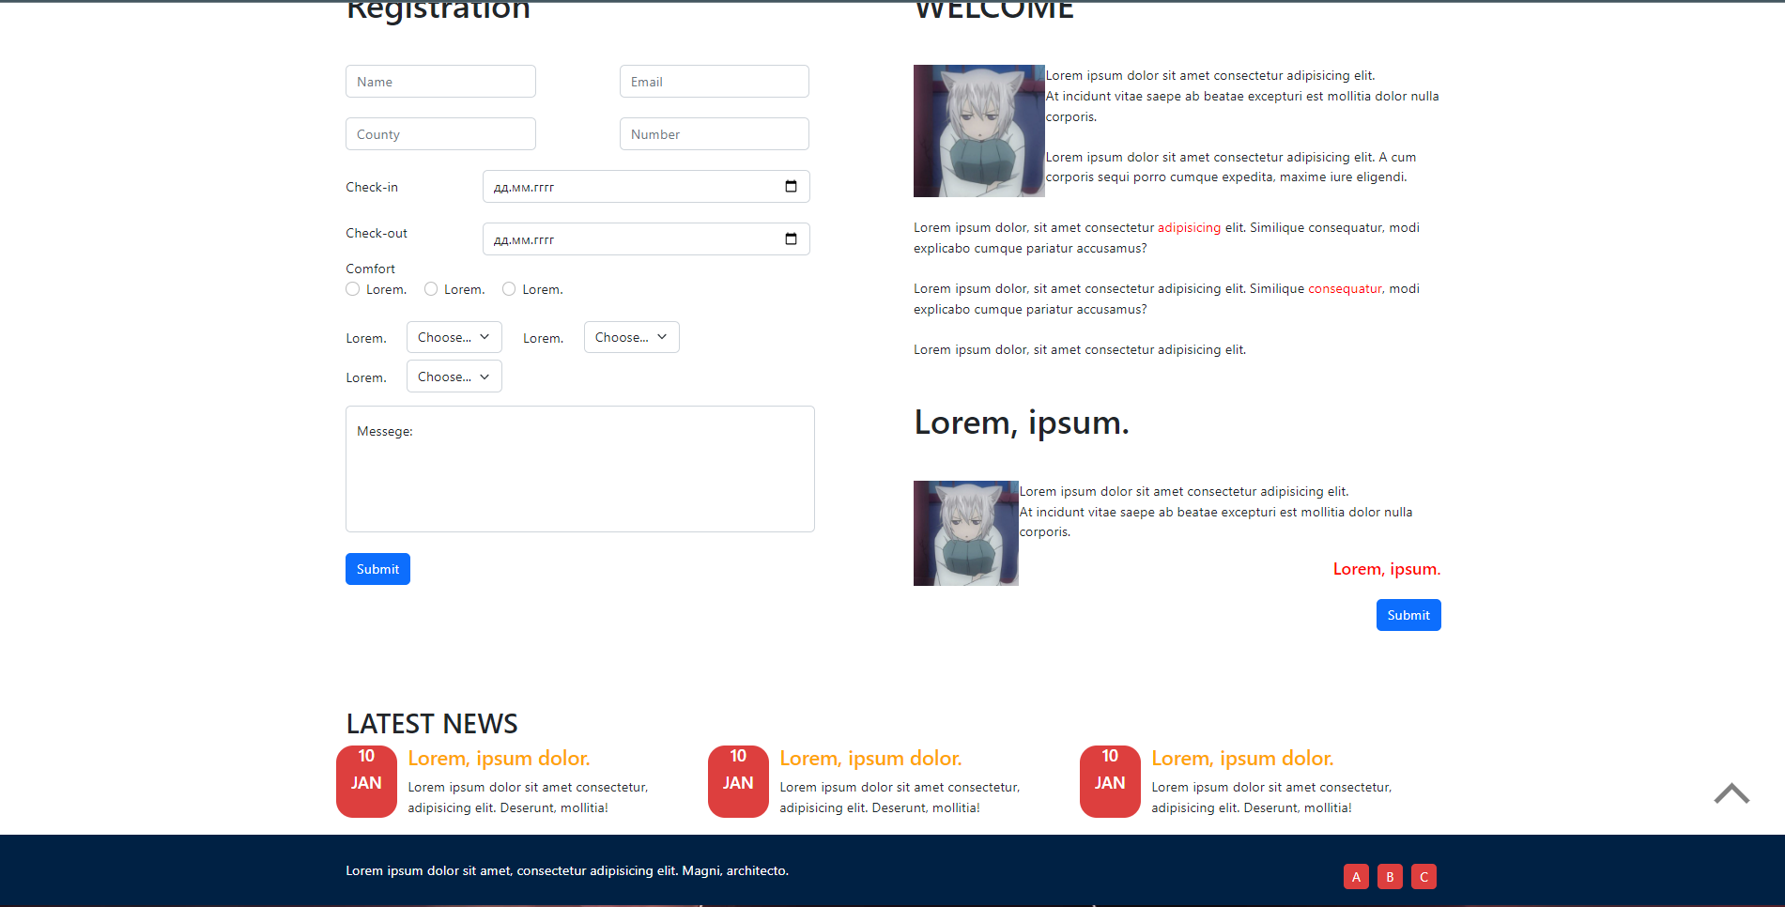

**HTM L:**

<!DOCTYPE *html*>

<html *lang*="en">

  <head>

    <meta *charset*="UTF-8" />

    <meta *http-equiv*="X-UA-Compatible" *content*="IE=edge" />

    <meta *name*="viewport" *content*="width=device-width, initial-scale=1.0" />

    <link

*href*="https://cdn.jsdelivr.net/npm/bootstrap@5.2.0-beta1/dist/css/bootstrap.min.css"

*rel*="stylesheet"

*integrity*="sha384-0evHe/X+R7YkIZDRvuzKMRqM+OrBnVFBL6DOitfPri4tjfHxaWutUpFmBp4vmVor"

*crossorigin*="anonymous"

    />

    <link *rel*="stylesheet" *href*="task.css" />

    <title>Task</title>

  </head>

  <body>

    <script

*src*="https://cdn.jsdelivr.net/npm/bootstrap@5.2.0-beta1/dist/js/bootstrap.bundle.min.js"

*integrity*="sha384-pprn3073KE6tl6bjs2QrFaJGz5/SUsLqktiwsUTF55Jfv3qYSDhgCecCxMW52nD2"

*crossorigin*="anonymous"

    ></script>

    <div *class*="container-fluid px-0 position-absolute" *id*="slide">

      <div

*id*="carouselExampleInterval"

*class*="carousel slide"

*data-bs-ride*="carousel"

*data-interval*="true"

      >

        <div *class*="carousel-inner">

          <div *id*="text">YUMMI ANIME<img *src*="img/yummi.jpg" *alt*="" /></div>

          <div *class*="carousel-item active" *data-bs-interval*="4000">

            <img *src*="img/1.jpg" *class*="d-block w-100" *alt*="..." />

            <div *id*="text_slide">Kamisama Kiss</div>

            <div *class*="row text-bg-danger text-center h5 rounded" *id*="watch">

              <div *class*="col pt-4 pb-4">

                <a *href*="" *style*="display: block">WATCH</a>

              </div>

            </div>

          </div>

          <div *class*="carousel-item" *data-bs-interval*="4000">

            <img *src*="img/2.jpg" *class*="d-block w-100" *alt*="..." />

            <div *id*="text_slide">Sword Art Online</div>

            <div *class*="row text-bg-danger text-center h5 rounded" *id*="watch">

              <div *class*="col pt-3 pb-3">

                <a *href*="" *style*="display: block">WATCH</a>

              </div>

            </div>

          </div>

          <div *class*="carousel-item" *data-bs-interval*="4000">

            <img *src*="img/3.jpg" *class*="d-block w-100" *alt*="..." />

            <div *id*="text_slide">Plastic Memories</div>

            <div *class*="row text-bg-danger text-center h5 rounded" *id*="watch">

              <div *class*="col pt-3 pb-3">

                <a *href*="" *style*="display: block">WATCH</a>

              </div>

            </div>

          </div>

        </div>

        <button

*class*="carousel-control-prev"

*type*="button"

*data-bs-target*="#carouselExampleInterval"

*data-bs-slide*="prev"

        >

          <span *class*="carousel-control-prev-icon rounded-circle border p-4" *aria-hidden*="true"></span>

          <span *class*="visually-hidden">Previous</span>

        </button>

        <button

*class*="carousel-control-next"

*type*="button"

*data-bs-target*="#carouselExampleInterval"

*data-bs-slide*="next"

        >

          <span *class*="carousel-control-next-icon rounded-circle border p-4" *aria-hidden*="true"></span>

          <span *class*="visually-hidden">Next</span>

        </button>

      </div>

    </div>

    <!--  -->

    <div *class*="container" *id*="top">

      <div *class*="row alien-items-center text-bg-danger text-center h5 rounded">

        <div *class*="col pt-3 pb-3">

          <a *href*="" *style*="display: block">ABOUT</a>

        </div>

        <div *class*="col pt-3 pb-3">

          <a *href*="" *style*="display: block">HOT ANIME</a>

        </div>

        <div *class*="col pt-3 pb-3">

          <a *href*="" *style*="display: block">LIST</a>

        </div>

        <div *class*="col pt-3 pb-3">

          <a *href*="" *style*="display: block">BLOG</a>

        </div>

        <div *class*="col pt-3 pb-3">

          <a

*class*="nav-link dropdown-toggle"

*href*="#"

*id*="navbarDropdownMenuLink"

*role*="button"

*data-bs-toggle*="dropdown"

*aria-expanded*="false"

          >

            CONTACTS

          </a>

          <ul *class*="dropdown-menu" *aria-labelledby*="navbarDropdownMenuLink">

            <li><a *class*="dropdown-item" *href*="#">number</a></li>

            <li><a *class*="dropdown-item" *href*="#">email</a></li>

            <li><a *class*="dropdown-item" *href*="#">Something else here</a></li>

          </ul>

        </div>

      </div>

    </div>

    <!--  -->

    <div *class*="container" *id*="card">

      <div *class*="row row-cols-1 row-cols-md-3 g-3">

        <div *class*="col">

          <div *class*="card bg-dark text-white">

            <img *src*="img/1.jpg" *class*="card-img w-100" *alt*="..." />

            <div *class*="card-img-overlay">

              <h2 *class*="card-title text-center">Kamisama Kiss<br>

                <button *type*="button" *class*="btn btn-light">WATCH</button></h2></h2>

            </div>

          </div>

        </div>

        <div *class*="col">

          <div *class*="card bg-dark text-white">

            <img *src*="img/2.jpg" *class*="card-img w-100" *alt*="..." />

            <div *class*="card-img-overlay text-center">

              <h2 *class*="card-title">Sword Art Online<br>

                <button *type*="button" *class*="btn btn-light">WATCH</button></h2>

            </div>

          </div>

        </div>

        <div *class*="col">

          <div *class*="card bg-dark text-white">

            <img *src*="img/3.jpg" *class*="card-img w-100" *alt*="..." />

            <div *class*="card-img-overlay text-center">

              <h2 *class*="card-title">Plastic Memories<br>

                <button *type*="button" *class*="btn btn-light">WATCH</button></h2></h3>

            </div>

          </div>

        </div>

      </div>

    </div>

<!-- -->

<div *class*="container" *id*="form">

  <div *class*="row row-cols-md-2 row-cols-1 g-5">

<form *class*="col">

<h1>Registration</h1>

<div *class*="row mt-5 row-cols-md-2 row-cols-1">

  <div *class*="col">

    <input *type*="text" *class*="form-control w-75" *placeholder*="Name" *aria-label*="Name" *required*="required">

  </div>

  <div *class*="col">

    <input *type*="email" *class*="form-control w-75" *placeholder*="Email" *aria-label*="Email" *required*="required">

  </div>

</div>

<div *class*="row mt-4 row-cols-md-2 row-cols-1">

  <div *class*="col">

    <input *type*="text" *class*="form-control w-75" *placeholder*="County" *aria-label*="County" *required*="required">

  </div>

  <div *class*="col">

    <input *type*="text" *class*="form-control w-75" *placeholder*="Number" *aria-label*="Number" *required*="required">

  </div>

</div>

<div *class*="row mt-4">

  <label *class*="col-3 mt-2" *for*="in">

    Check-in

  </label>

  <div *class*="col-9">

    <input *type*="date" *class*="form-control" *aria-label*="Date" *id*="in" *required*="required">

  </div>

</div>

<div *class*="row mt-4">

  <label *class*="col-3" *for*="out">

    Check-out

  </label>

  <div *class*="col-9">

    <input *type*="date" *class*="form-control" *aria-label*="Date"  *id*="out" *required*="required">

  </div>

</div>

<div *class*="row mt-1">

  <div *class*="col">

    Comfort

  </div>

</div>

<div *class*="form-check form-check-inline">

  <input *class*="form-check-input rounded-circle" *type*="checkbox" *value*="" *id*="flexCheck1">

  <label *class*="form-check-label" *for*="flexCheck1">

    Lorem.

  </label>

</div>

<div *class*="form-check form-check-inline">

  <input *class*="form-check-input rounded-circle" *type*="checkbox" *value*="" *id*="flexCheck2">

  <label *class*="form-check-label" *for*="flexCheck2">

    Lorem.

  </label>

</div>

<div *class*="form-check form-check-inline">

  <input *class*="form-check-input rounded-circle" *type*="checkbox" *value*="" *id*="flexCheck3">

  <label *class*="form-check-label" *for*="flexCheck3">

    Lorem.

  </label>

</div>

<div *class*="row mt-4">

  <label *class*="col-auto mt-2" *for*="autoSizing1">

    Lorem.

  </label>

  <div *class*="col-auto">

    <select *class*="form-select" *id*="autoSizing1">

      <option *selected*>Choose...</option>

      <option *value*="1">One</option>

      <option *value*="2">Two</option>

      <option *value*="3">Three</option>

    </select>

  </div>

  <label *class*="col-auto mt-2" *for*="autoSizing2">

    Lorem.

  </label>

  <div *class*="col-auto">

    <select *class*="form-select" *id*="autoSizing2">

      <option *selected*>Choose...</option>

      <option *value*="1">One</option>

      <option *value*="2">Two</option>

      <option *value*="3">Three</option>

    </select>

  </div>

</div>

<div *class*="row mt-2">

  <label *class*="col-auto mt-2" *for*="autoSizing3">

    Lorem.

  </label>

  <div *class*="col-auto">

    <select *class*="form-select" *id*="autoSizing3">

      <option *selected*>Choose...</option>

      <option *value*="1">One</option>

      <option *value*="2">Two</option>

      <option *value*="3">Three</option>

    </select>

  </div>

</div>

<div *class*="form-floating mt-3" *id*="area">

  <textarea *class*="form-control" *placeholder*="Leave a comment here" *id*="floatingTextarea2" *style*="height: 150px"></textarea>

  <label *for*="floatingTextarea2">Messege:</label>

</div>

<div *class*="col-auto mt-4">

  <button *type*="submit" *class*="btn btn-primary">Submit</button>

</div>

</form>

<!-- </div> -->

<div *class*="col" *id*="right">

  <h1>WELCOME</h1>

<p *class*="mt-5" *id*="img"><img *src*="img/1.jpg" *alt*="" *class*="w-25 h-25 float-left">

Lorem ipsum dolor sit amet consectetur adipisicing elit.<br> At incidunt vitae saepe ab beatae excepturi est mollitia dolor nulla corporis.<br><br>

Lorem ipsum dolor sit amet consectetur adipisicing elit. A cum corporis sequi porro cumque expedita, maxime iure eligendi.

</p>

<p *class*="mt-4">Lorem ipsum dolor, sit amet consectetur <span>adipisicing</span> elit. Similique consequatur, modi explicabo cumque pariatur accusamus?</p>

<p *class*="mt-4">Lorem ipsum dolor, sit amet consectetur adipisicing elit. Similique <span>consequatur</span>, modi explicabo cumque pariatur accusamus?</p>

<p *class*="mt-4">Lorem ipsum dolor, sit amet consectetur adipisicing elit.</p>

<h1 *class*="mt-5">Lorem, ipsum.</h1>

<p *class*="mt-5" *id*="img"><img *src*="img/1.jpg" *alt*="" *class*="float-left" *id*="img2">

Lorem ipsum dolor sit amet consectetur adipisicing elit.<br> At incidunt vitae saepe ab beatae excepturi est mollitia dolor nulla corporis.

<h5 *class*="text-right"><span>Lorem, ipsum.</span></h5>

</p>

<div *class*="col-auto mt-4" *id*="more">

  <button *type*="submit" *class*="btn btn-primary">Submit</button>

</div>

</div>

</div>

</div>

<section *class*="news container"><h2>LATEST NEWS</h2><div *class*="row"><div *class*="col-4"> <div *class*="row"><div *class*="col-2 red"><h5>10</h5><h5>JAN</h5></div><div *class*="col-10"><h4>Lorem, ipsum dolor.</h4><span>Lorem ipsum dolor sit amet consectetur, adipisicing elit. Deserunt, mollitia!</span></div></div></div><div *class*="col-4"> <div *class*="row"><div *class*="col-2 red"><h5>10</h5><h5>JAN</h5></div><div *class*="col-10"><h4>Lorem, ipsum dolor.</h4><span>Lorem ipsum dolor sit amet consectetur, adipisicing elit. Deserunt, mollitia!</span></div></div></div><div *class*="col-4"> <div *class*="row"><div *class*="col-2 red"><h5>10</h5><h5>JAN</h5></div><div *class*="col-10"><h4>Lorem, ipsum dolor.</h4><span>Lorem ipsum dolor sit amet consectetur, adipisicing elit. Deserunt, mollitia!</span></div></div></div></div></section>

<footer><a *class*="return" *href*="#top"></a><div *class*="container"><span>Lorem ipsum dolor sit amet, consectetur adipisicing elit. Magni, architecto.</span><button>C</button><button>B</button><button>A</button></div></footer>

  </body>

</html>

**CSS:**

@media only screen and (max-width: 561px) {

*#text_slide* {

    font-size: 5em;

  }

*#text* {

    font-size: 2em;

  }

}

@media only screen and (max-width: 768px) {

*#form* {

    padding-top: 1000px;

    input[*type*="text"],

    input[*type*="email"] {

      margin-top: 5px;

    }

  }

}

a {

  text-decoration: none;

}

*.col* {

  a {

    transition: 0.3s;

    color: black;

  }

  &*:hover* > a {

    color: white;

  }

}

*#top* {

  position: relative;

}

img {

  height: 800px;

}

*#text* {

  z-index: 1;

  position: absolute;

  top: 22%;

  left: 50%;

  transform: translate(-50%, -50%);

  font-size: 2.5em;

  font-family: "Raleway";

  img {

    position: absolute;

    width: 32px;

    height: 32px;

    top: -20%;

  }

}

*#slide* {

  span {

    transition: 0.3s;

  }

  button*:hover* {

    span {

      background-color: rgb(241, 82, 82);

    }

  }

*#text_slide* {

    color: black;

    position: absolute;

    top: 49.5%;

    left: 50%;

    transform: translate(-50%, -50%);

    font-size: 6em;

    font-family: "Raleway";

  }

}

*#watch* {

  z-index: 1;

  position: absolute;

  top: 80%;

  left: 50%;

  width: 200px;

  transform: translate(-50%, -50%);

  font-size: 2.5em;

}

*#card* {

  margin-top: 650px;

  height: 500px;

  div {

    height: 500px;

    div {

      height: 500px;

      h2 {

        position: relative;

        top: 50%;

      }

    }

  }

}

*.btn-light* {

  color: red;

  width: 40%;

  transition: 0.3s;

}

*#form* {

  margin-top: 120px;

  input[*type*="date"] {

    width: 84%;

  }

*#area* {

    width: 89%;

  }

  textarea {

    resize: none;

  }

*#img* {

    display: flex;

*#img2* {

      width: 20%;

      height: 20%;

    }

  }

  span {

    color: red;

  }

*.text-right* {

    position: relative;

    top: -6%;

    text-align: right;

  }

*#more* {

    position: relative;

    top: -6%;

    text-align: right;

  }

}

section*.news* {

  margin-top: 40px;

  h4 {

    color: orange;

  }

*.red* {

    background-color: #dd3f3e;

    border-radius: 20px;

    height: 85px;

    color: #fff;

    text-align: center;

  }

}

footer {

  margin-top: 20px;

  color: #fff;

  padding: 30px 0;

  background-color: #002144;

  button {

    color: #fff;

    float: right;

    height: 30px;

    width: 30px;

    background-color: #dd3f3e;

    border: none;

    border-radius: 5px;

    margin: 5px;

  }

*.return* {

    position: fixed;

    top: 87%;

    height: 30px;

    width: 30px;

    bottom: 30px;

    right: 50px;

    border-top: 6px solid grey;

    border-left: 6px solid grey;

    transform: rotate(45deg);

  }

}

***Висновки:*** я навчився створювати адаптивні веб-сторінки за допомогою фреймворка Bootstrap.